1. Multifunctional Surfactants : Wettng & Defoaming agents
2. High Performance Wetting Agents (Dynol series)
3. Defoamers & Deaerators (수계 소포제)
4. Grinding Aids for Stabilizing (수/유계 분산조제)
5. Dispersants (수/유계 안료분산제)

1. Multifunctional Surfactants : Wettng & Defoaming agents
1) Surfynol 104 grade
▶구조 :
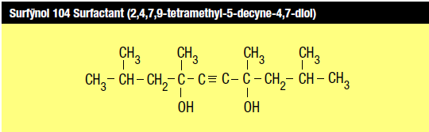
- 상온에서는 백색 왁스성상을 지니고, 용제로 희석하여 사용가능.
▶특징 :
① Acetylene 삼중결합과 중앙에 위치한 친수기(OH기)에 의한 표면장력 저하에 따른 Wetting성 부여
② 삼중결합을 중심으로 양쪽에 Branch화된 methyl그룹(소수성)에 의한 기포억제 효과
③ Cloud Point가 없으며, 넓은 범위의 PH(PH 3~12)에서 안정함.
④ Aliphatic solvent를 제외한 대부분의 solvent에 soluble함.

▶용제에 따른 제품 분류
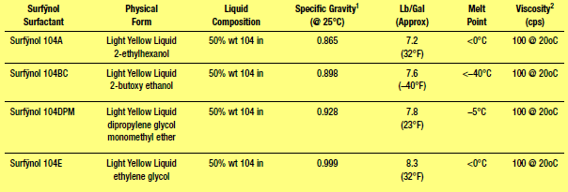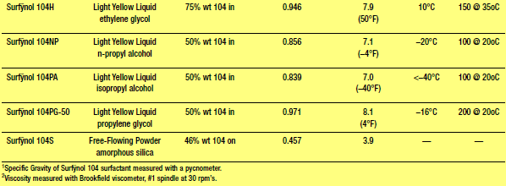

▶적용분야 :
① 수계도료(자동차, DIY목공, 건축용, 플라스틱용)및 코팅(종이, 나무, 금속 등)
② 수계인쇄잉크(Flexo, Gravure, inkjet ink, OPV, Fountain Solution)
③ 감압접착제(Pressure Sensitive Adhesive)
④ 농약약재
⑤ 염료(분산염료, Azo Dye)
⑥ 금속가공유, 금속세정제, 가정용세정제, 반도체 세정제
⑦ Concrete admixture, 시멘트 Mortar

2) Surfynol 400 grade
▶구조 : Surfynol 104에 ethylene oxide 가 결합된 구조
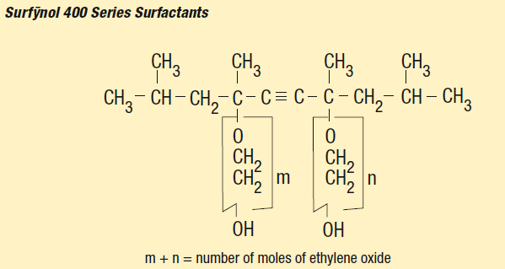
▶특징
①첨가된 ethylene oxide 는 hydrophilic 성질을 증가시킴. 즉, 소포성을 향상시킴.
②EO mole수에 따라서 low-foaming, nonfoaming 또는 defoaming wetting agent로 다양하게 작용한다.
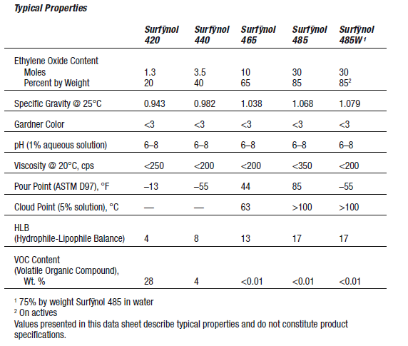
3) Surfynol 2502 surfactant
: Surfynol 104에 EO(Ethylene Oxide)와 PO(Propylene Oxide)를 부가한 제품으로서, Surfynol 440과 465 중간 물성을 띈다.
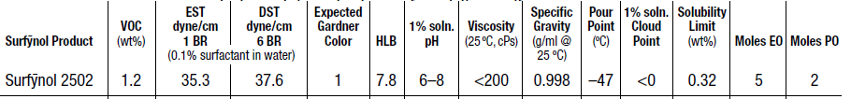

3) Surfynol AD-01 surfactant
: Surfynol 104의 액체성상으로, Zero VOC, APE-Free타입의 친환경형 수계 계면활성제
Surfynol 104과 유사한 물성을 보이며, low DST와 빠른 소포력을 갖는다.

 | EST (0.1 wt%) | DST (0.1 wt%) | VOC (%) | HLB | ACITIVITY (%)
EnviroGem® AD-01 | 35.2 | 36.4 | 0 | 4 | 100

2. High Performance Wetting Agents (Dynol series)
1) Super wetting agent & Coalescing surfactant : Dynol 360
 | EST  (정적표면장력) | DST  (동적표면장력) | VOC* | HLB | Activity %
Dynol 360 | 28.0 | 35.0 | 2.7/0 | 3~4 | 100
* Wt % VOC (U.S. EPA Method 24) : 0
VOC (European Solvent and Paint Directives) : 0 ▶ 특징 :

1) 실리콘계/ 불소계 계면활성제를 능가하는 낮은 정적/동적 표면장력 형성
2) 뛰어난 기포제어 능력
3) Plastic과 같이 낮은 에너지 표면을 갖는 기재에서 우수한 습윤효과
4) Fountain Solution에서 소포제 역할
5) Coalescing surfactant로서, MFFT(최소도막형성온도)를 낮추는 효과를 가짐.
=> 소량 첨가하여 coalescing solvent의 사용량을 50% 이상 감소
6) 수계에서 우수한 상용성

2) Non Siloxane Super wetting agent : Dynol 604/607/800/810
 | EST*(정적표면장력) | DST*(동적표면장력) | VOC(%) | IONIC NATURE
Dynol 604 | 25.8 | 28.4 | < 1.5 | NONIONIC
Dynol 607 | 26.0 | 27.0 | < 1.45 | NONIONIC
★Dynol 800 | 26 | 32 | 0 | NONIONIC
★Dynol 810 | 26 | 32 | 0 | NONIONIC
* at 0.1wt % in water(mN/m)
★: 신제품

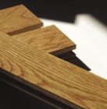
▶ 특징:
1) 비 실리콘계. 비 불소계
2) EST 와 DST 를 현저하게 낮춤.
3) 뛰어난 flowing성과 wetting성.
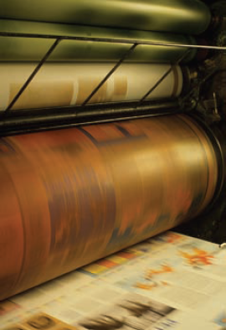
4) 저기포성 / 뛰어난 소포력
5) 환경친화적 – VOCs, APEs, HAPs FREE
6) 100% active
7) 혼합하기 쉽고, 상용성 좋음

▶ 적용분야 : 다양한 범위의 수계 시스템에 권장됨.
• Graphic Arts
– Printing Inks, Overprint varnishes, Fountain solution
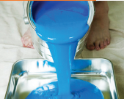
• Coatings
– Automotive OEM and refinish, OEM and DIY wood coatings, Metal coatings,
Leather coating, Plastic coatings.
• Adhesives

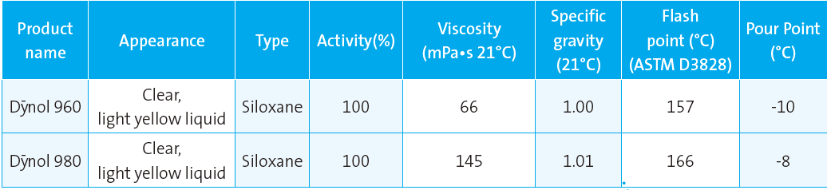
3) Siloxane Super wetting agent : Dynol 960/980

3. Defoamers & Deaerators (수계 소포제)
1) Molecular Defoamers
: wetting defoamer라고도 불리며, wetting성과 defoaming성을 동시에 갖는다.
수계 시스템에 상용성이 좋아, 기포를 안정화하는 surfactant 사이에 위치하여 표면장력 차이를 발생시키고, foam lamella
층을 약화시켜 기포를 제거한다.
Grade |  | Application
SURFYNOL® 104 grades  SURFYNOL® AD01 | 비이온성 wetting agent and molecular defoamer. | Waterborne Inks, Coatings. Adhesive
SURFYNOL® DF-110C/D/L | 비이온성 organic molecular defoamer  ▶ 주요기능 : microfoam 제거, long-lasting foam control, defect-free foam control, and good dynamic wetting | Printing ink, Concrete system, Fountain Solution, Ceramics, Paper coating, Grouts and mortars
SURFYNOL® MD-20 | 비이온성 organic defoaming and wetting agent. | Coatings - Automotive, Wood, Metal, Architectural  Graphic Arts - Printing inks, Fountain solutions  Adhesives, Oil&gas processing, 반도체 세정제 등.

2) Organic Oil Defoamers
Grade |  | Application
SURFYNOL® DF-70 | Waterborne Inks, Coatings. Adhesive
SURFYNOL® DF-75 | Printing ink, Concrete system, Fountain Solution, Ceramics, Paper coating, Grouts and mortars
SURFYNOL® DF-220 | Coatings - Automotive, Wood, Metal, Architectural  Graphic Arts - Printing inks, Fountain solutions  Adhesives, Semi-conductor cleaner
AIRASE 4500 | Waterborne Inks, Overprint varnishes, Adhesives, Coatings, Architectural paints.
3) Siloxane Defoamers
Grade Application
SURFYNOL® DF-58 | Coating (Pigment Grinding and Dispersion)
SURFYNOL® DF-62 | Printing inks, Industrial Maintenance Coating, Wood coating, Adhesive,  Paper coating, Latex dipping
SURFYNOL® DF-66 | Inks, Coating, Light duty industrial maintenance, Pigment dispersions
SURFYNOL® DF-695  SURFYNOL® DF-178 | Graphic arts (Pigment Grinding and Dispersion, Let down)  Polyurethane dispersion, Polyurethane/acrylic hybrid, Two –component epoxy  Formulations, Pigmented coatings, Flexographic new ink

★New Siloxane Defoamer Line : Airase Defoamers

 | A5100, A5200 | A5300, A5400 | A5500, A5600 | A5700
Performance with  Increasing PVC | Excellent | Very good | Good | Poor
High Shear stability | Excellent | Very good | Good | Poor
End uses(적용분야) | Colorants,  High concentrated  Pigment millbases | Primers, Inks,  Semi-gloss paints | Gloss paints,  Wood clear coats | High gloss paint  Auto OEM,  Plastic coating

★ New Siloxane Deaerators : Airase 8070
▶특징
① 계 안에 존재하는 작은 사이즈의 기포(microfoam)을 제거하는 소포제
② 점도가 크거나, airless spray와 같이 약한 shear가 가해지는 조건에서 microfoam 제거에 용이
③ 수계 coating에서 발생하는 핀홀, solvent popping 문제해결
④ 수계 및 무용제계에서 사용가능하며, wood coating, metal,plastic, concrete coating에 추천.

4. Grinding Aids for Stabilizing (수/유계 분산조제)
 | Grade | HLB | Activity  (in water) | Description
CARBOWET® GA211 |  | 8 - 11 | 83% | 1. A nonionic pigment grind aid and wetting  2. Provides low-foam pigment and substrate wetting  3. Improve the milling process and pigment color
SURFYNOL® TG |  |  | 83% | 1. A nonionic pigment grind aid and wetting agent  2. Improved pigment wetting  3. Greater color development  4. Reduced pigment “cut-in” time  5. Low foam  6. Reduced water sensitivity
CARBOWET® GA100 |  | 10~11 |  | 1. Milling efficiency improvement for faster and greater color  development.  2. Low foam with dynamic pigment wetting  3. 계의 점도, 내수성, 광택, 건조시간 등에 영향을 주지 않음  4. solvent free, APEs free.
CARBOWET® GA210 |  | ~13 | 88% | 1. 적용분야: 유/무기 안료분산, 인쇄용잉크, 건축용 코팅, 점,접착제, 농약 등.
CARBOWET® GA221 |  | 11 - 15 | 70% | 1. Nonionic grind aid for pigment wetting  2. Improved color development  3. Control the mill base foam  4. Low viscosity
SURFYNOL® GA |  |  | 70% | 1. Nonionic pigment grind aids  2. Low foam
SURFYNOL® CT121 |  |  | 70% | 1. Nonionic pigment grind aids
SURFYNOL® CT136 |  | 11 - 20 | 52% | 1. Anionic/nonionic pigment dispersant and wetting  2. Grind aid for High HLB organic & inorganic pigment  3. 형광 Pigment 분산에 유용
SURFYNOL® CT131 |  |  | 52% | 1. Anionic / nonionic pigment wetting & dispersing
SURFYNOL® CT231 |  |  | 52% | 1. Nonionic pigment grind aids  2. Control mill base foam  3. Low viscosity at high pigment loadings
SURFYNOL® CT324 |  | 13 - 20 | 46% | 1. Anionic / nonionic grind aids for organic/ inorganic pigments  2. Pigment wetting and dispersing  3. Low foam  4. High pigment solids at optimal working viscosities
SURFYNOL® CT171 |  |  | 38% | 1. Anionic / nonionic pigment grind aid  2. Long-term dispersion and finished ink viscosity stability  3. Viscosity reduction for higher pigment loadings  4. Good foam control  5. Both resin and resin-free dispersions
SURFYNOL® CT141 |  |  |  | 1. Anionic / nonionic pigment dispersant  2. Useful with high HLB pigments such as carbon black  3. Compatible with acrylic resins and polymers used in printing inks and  coatings.  4. Viscosity control in a finished ink
5. Dispersants (수/유계 안료분산제) – ZETASPERSE
1) Resin-free system Dispersant
 | Activity | Reference (Usage)
Zetasperse 1200 | 45% active in water | Iron oxide (PY42,PR101,PBK11), Titanium oxide (PW6),  기타 무기안료용 분산제  High pigment loading시 양호한 분산안정성을 보임
Zetasperse 2300 | 95% active in water | Cost-effective for Organics / Inorganics pigments
Zetasperse 2500 | 40% active in water | Metal salt red (lithol rubine - PR57:1)  Red lakes (PR57:x, PR48:x, PR49:x, others)
Zetasperse 3100 | 40% active in water | Carbon black(all types)  Inorganics(PW6, PY42, PR101, and others)
Zetasperse 3400 | 29% active in water | Quinacridones(PV19, PR122, and others),  Perylenes(PR179, PR123, and others)  Dioxazine(PV23, PV37, and others)  Metal-azo complex(PR257, PY150, others)
★Zetasperse 3600 | 52% active in water | Surfynol CT-131 CT-136, CT-231 대응 수계안료분산제.  Resin-free. All organic and carbon black pigments
Zetasperse 3700 | 40% active in water | DPP(PR254, PR264, PO73, and others)  Azo(PY74, PR170, PR120, PO5 and others)  Dioxazine(PV23, PV37, and others)  Phthalocyanine(PG7, PG36, PB15:x, others)

2) Resin-containing system Dispersant
Zetasperse 170 |  | Nonionic wetting agent & dispersing stabilizing surfactant  Carbon black, Titanium oxide pigment dispersion에 분산안정성을 향상.
Zetasperse 179 |  | Nonionic, High HLB surfactant.  Organic/Inorganic , carbon black dispersion에 분산안정제로 사용
Zetasperse 182
Zetasperse 2500 | 40% active in water | Metal salt red (lithol rubine - PR57:1)  Red lakes (PR57:x, PR48:x, PR49:x, others)
★Zetasperse 3600 | 52% active in water | Surfynol CT-131 CT-136, CT-231 대응 수계안료분산제.  Resin-free. All organic and carbon black pigments

